CPF Self Service Portal
Introduction
The purpose of this document is to give the intended users step-by-step operating instructions in applying the claim-related activities in CPF Self Service System.
This user’s guide provides complete and detailed information on performing the CPF Self Service functions in CPF SSP System.
This guide includes:
- Procedures for the tasks you need to perform
- Information as a screenshot for related process

About CPF Self Service
The CPF Self Service facilitates the online process for different types of claim raises and approvals. After final approval by CPF Self Service, the claim goes to the payroll CPF system for amount sanction.
CPF SSP operates by four types of users having different roles like -
- User role
- Admin role
- CPF Admin role
- Super User role
Role wise action perform by user –
- User Role - a) Claim Raise b) Re-Apply Claim in case claim got rejected b) Raised Claim Tracking c) CPF Clip Generate d) Change Password
- Admin Role - a) Claim Raise b) Raised Claim Tracking c) Claim Approval d) Claim Reject e) Claim Assign to other Admin with same location or different location f) CPF Clip Generate g) Requested Claim Report Generate h) Change Password
- CPF Admin Role - a) Claim Raise b) Raised Claim Tracking c) Claim Approval d) Claim Reject e) Claim Assign to other CPF Admin which having same location as assigner CPF Admin f) CPF Clip Generate g) Requested Claim Report Generate h) Change Password
- Super User Role – a) Role Mapping b) Revoke Role c) CPF Clip Generate d) Requested Claim Report Generate e) Change Password
Note: - System does not support multiple roles on a single user id or employee id at a single point in time.

Claim Raise Prerequisites –
- KYC document upload is mandatory before a claim is raised on the home page. In KYC documents need to be uploaded as UAN doc, Salary Slip, etc. To upload more than one document as a single upload, you need to merge all docs as a single doc.
- At Least, one user must be present at the claim-raised location with an admin role.

CPF SSP Data Flow Diagram -

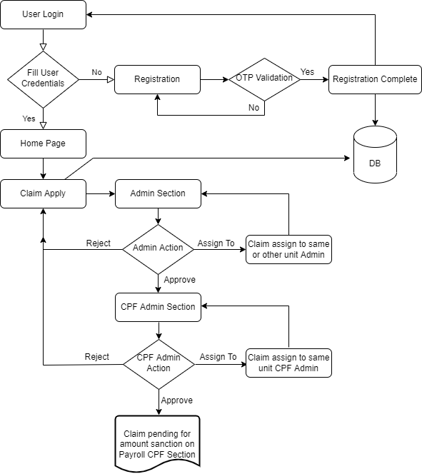

Employee Registration
- Open the URL of CPF Self Service Portal -https://fcilekha.in:7778/CpfSelfService/login. The login page will get a display.
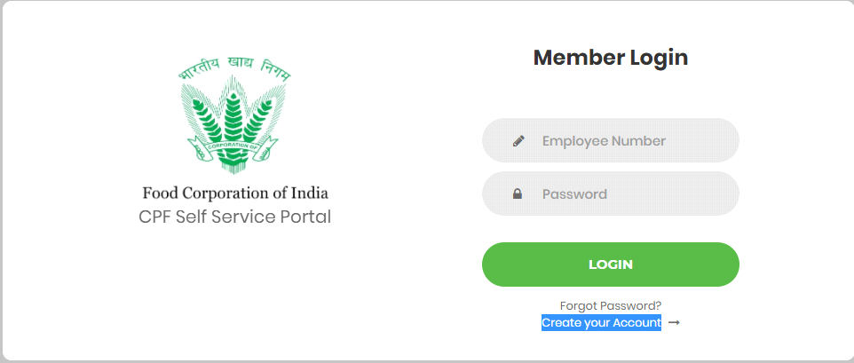
- Login page -> Create Your Account
- Click on the link Create your Account link for the registration of an employee. Now registration form will get open.
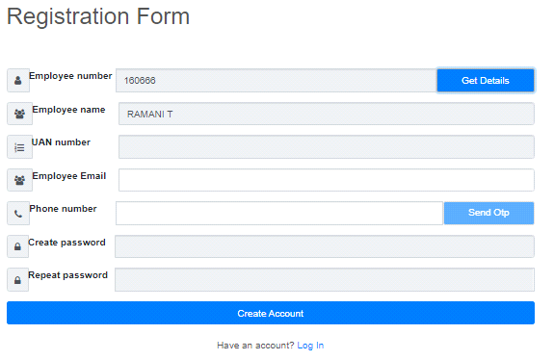
- Enter the Employee Number and Press Get details. Employee details will get displayed.
- Enter the Email Address and Mobile Number. (Note – Mobile Number should be Unique and should not be registered with another employee.)
- Press Send OTP button. An OTP will be sent to your Mobile Number.
- OTP screen will appear. Enter the OTP on the screen and submit.
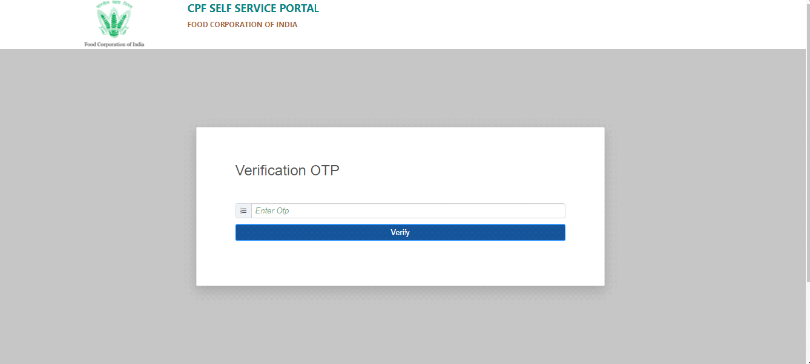
- After OTP validation is successful, the user needs to enter the Create Password and Repeat Password. If OTP validation failed system does not allow you to enter your password.
- Press Create Account Button. Your Registration Process will get completed.
Forget Password -
- Open the URL of CPF Self Service Portal - https://fcilekha.in:7778/CpfSelfService/ Login page will get displayed
- Login page ->Forget Password
- Click on Forgot Password Link. Forgot Password window will get open. 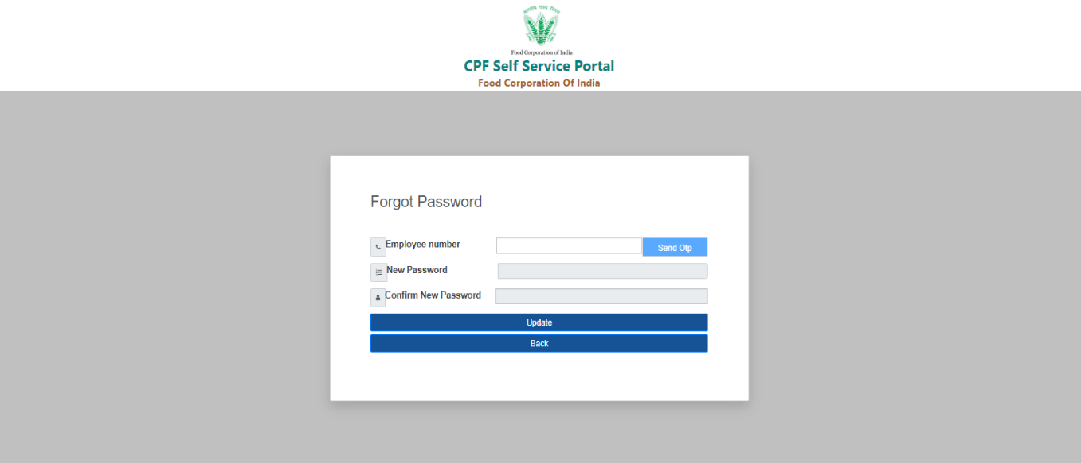
- Enter the Employee Number and press Send OTP button. OTP will be sent to your registered mobile number.
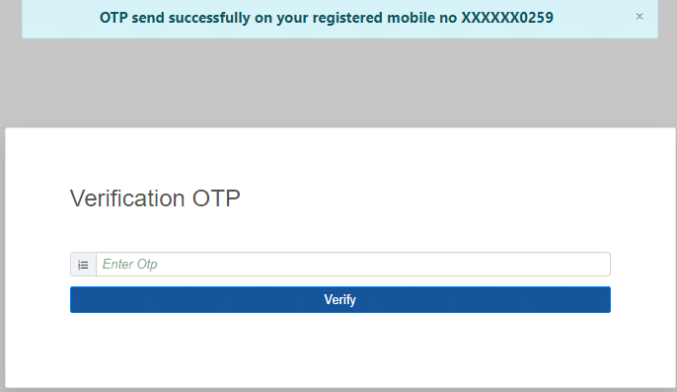

- Enter the OTP and press Verify button.
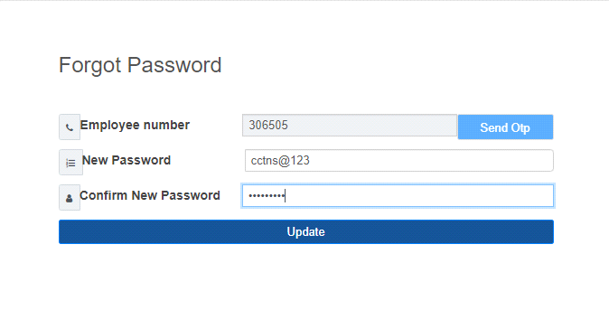
- Now enter the new Password and Confirm Password and Press Update Button.
- Password will get updated and redirect to Login Page.
User Login -
Password change process –
- Open the URL of CPF Self Service Portal -http://fcilekha.in:7778/CpfSelfService/. The login page will get displayed
- Enter the Employee Number and Password. The home page will display.

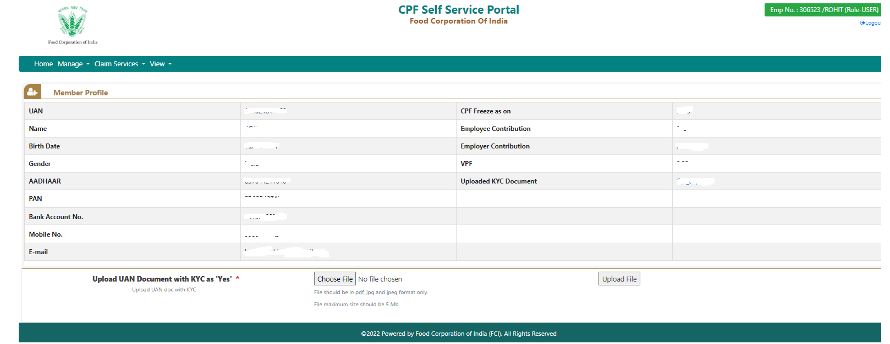

- Here you can see your details like UAN, Name, Birth Date, Aadhaar, PAN, etc. with Employer and Employee contribution.
Note: - Before going to raise your claim, must upload the KYC document on the home page. UAN document would be preferable along with salary slip and CPF slip etc. as a KYC document. It’s a mandatory document for any kind of claim raised.
- Now go to main menu Manage -> Change Password
- Click on the Change Password. The page will get open to change the password.
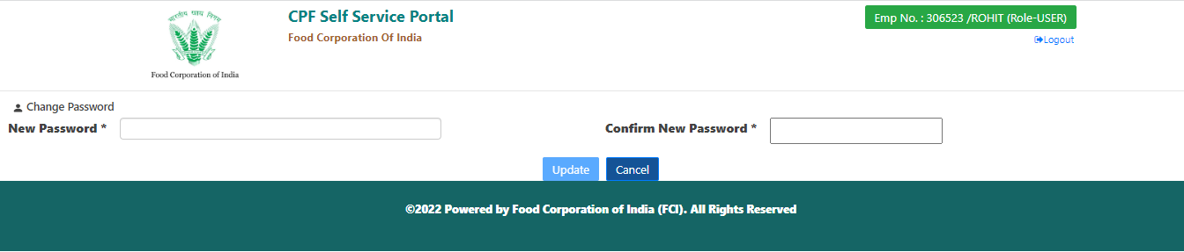
- Now enter the new Password and Confirm Password and Press Update Button.
- Password will get updated.

Claim Raise Process –
- Go to the main menu Claim Services -> Raise Claim Request
- Claim Request form will get display.
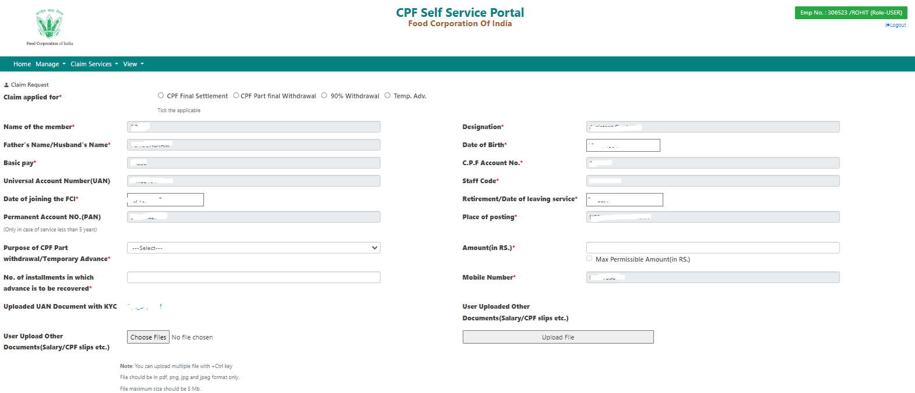
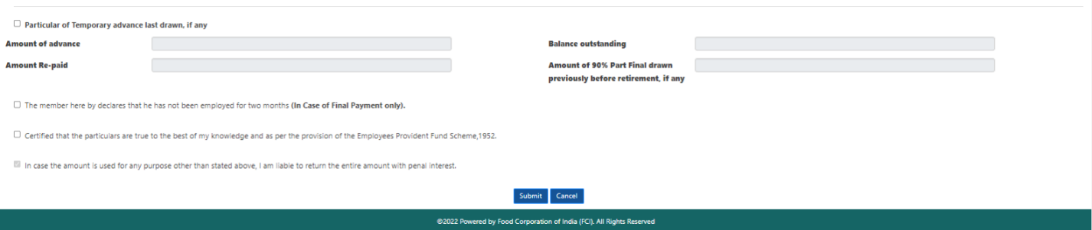
- Select the Radio Button for Claim applied for options.
- Select the purpose of the Claim.
Note: - Purpose dropdown populates only for two cases as CPF Part Final Withdrawal and Temp. Adv.
- Enter the Amount.
- Select the applicable checkbox and press Submit button. Claim request will be raised.
Note: - First checkbox is only applicable to resigned employees. No need to opt for this option in general conditions.
- Now you can track your Request status using the main menu Claim Service-> Request Status. Here you have two options “History” and “View” through which you can track your claim progress and view complete claim detail respectively.

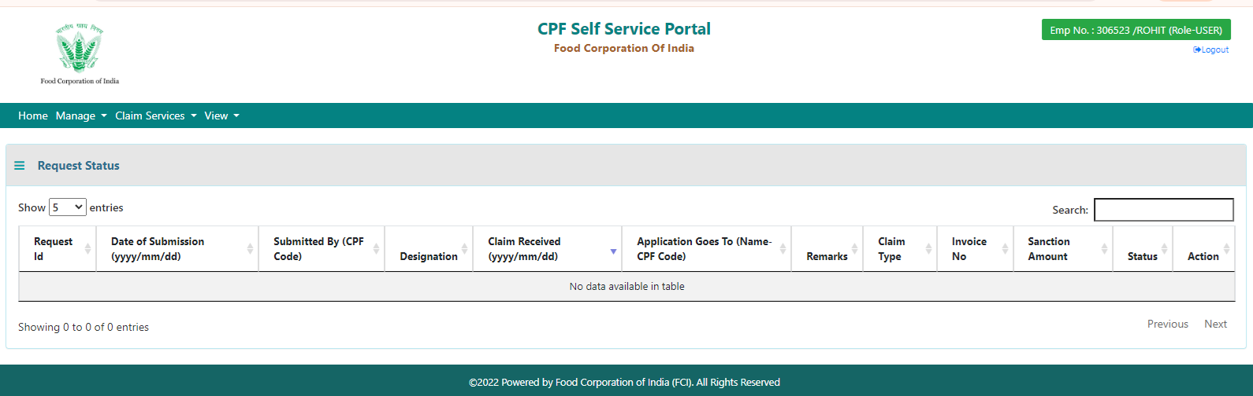

- The history form opens in a new tab.

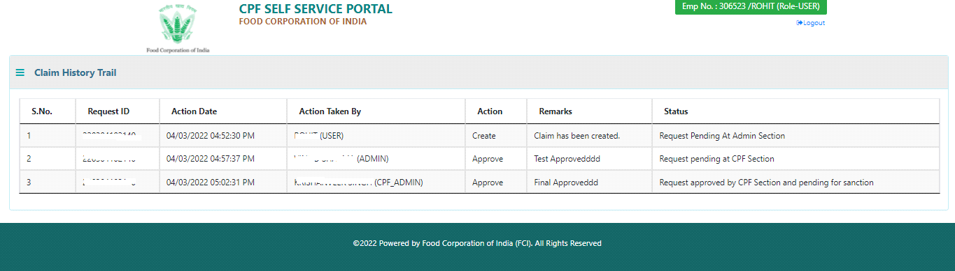
- After successful submission, the claim has to go respective Admin who is present in the same location as the user for approval.
Note:
The system can allow users to raise four type of claim through CPF SSP portal:
- Final Settlement – One time in the entire service period and
a. If member superannuating, he/she may apply for final settlement of CPF two months before the date of retirement.
b. If member has resigned from FCI, he/she may apply for CPF Final settlement any time after his/her resignation.
- Part Final Withdrawal -- Two time for COVID-19 and Six time for other purposes.
- 90% Withdrawal – One time in the entire service period and a member can apply for CPF 90% withdrawal within 1 year of his/her retirement.
- Temp Adv. -- User can raise multiple time this request if previous advance, if any, taken is fully recovered.

CPF Slip Generate process –
- After login go to the main menu View -> My CPF Slip
- Select from and to year then click the “Generate Report” button to generate a CPF slip.
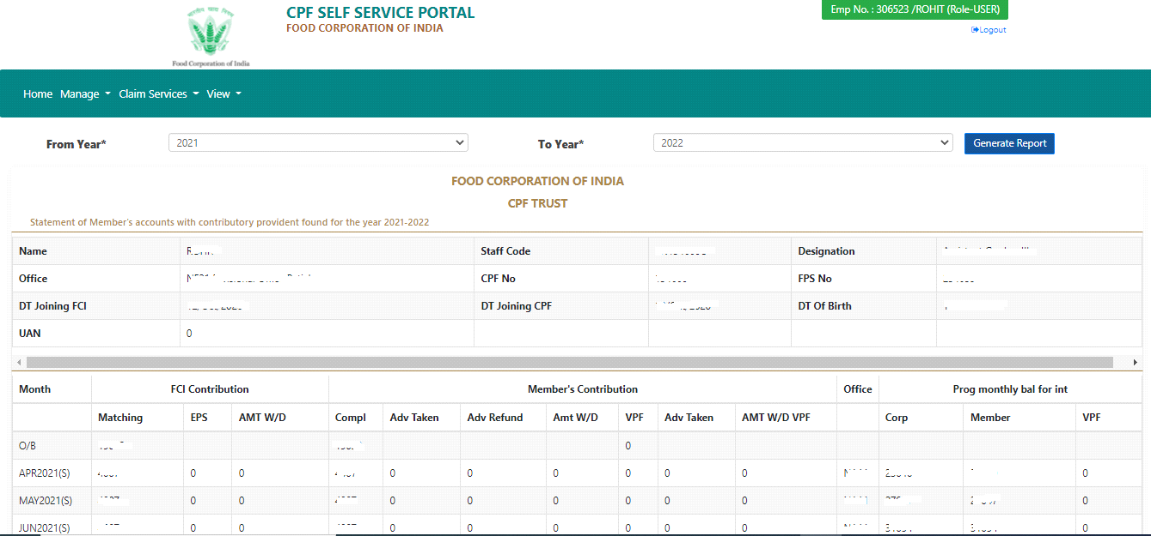
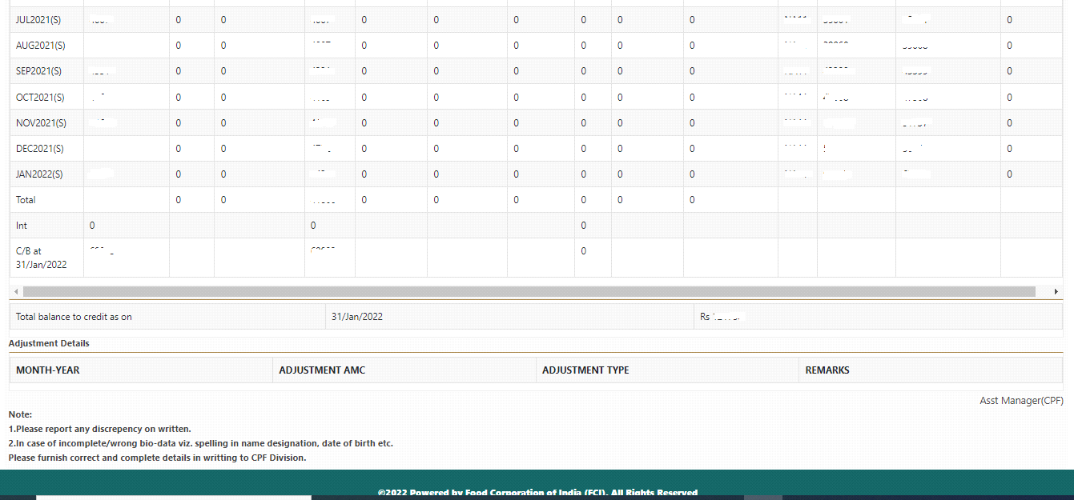

Admin Login -
In the Admin section, the only change has occurred in the “Claim Service” and “View” main menu, the rest of the things are the same as the user login section environment.
Admin Approval –
- Login using Admin credentials in CPF Self Service Portal.
- Click on Claim Services and go to the Pending Requests option. You will get the list of claims.
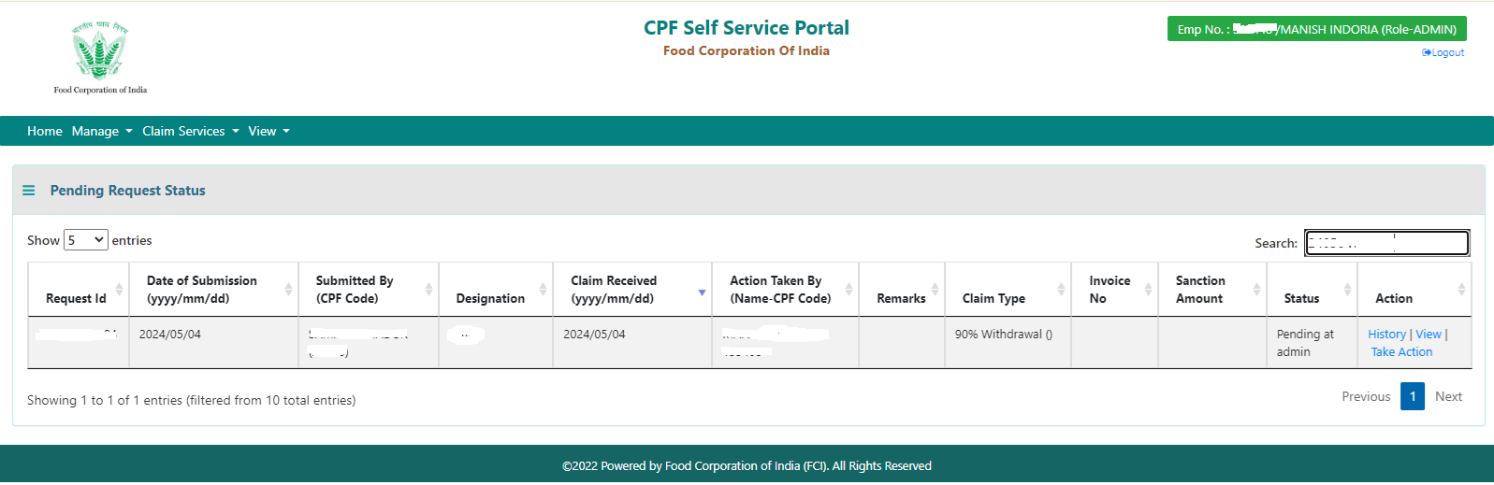
- Here You can view and Take action on these claims. Click on the Take Action link and get the following screen.
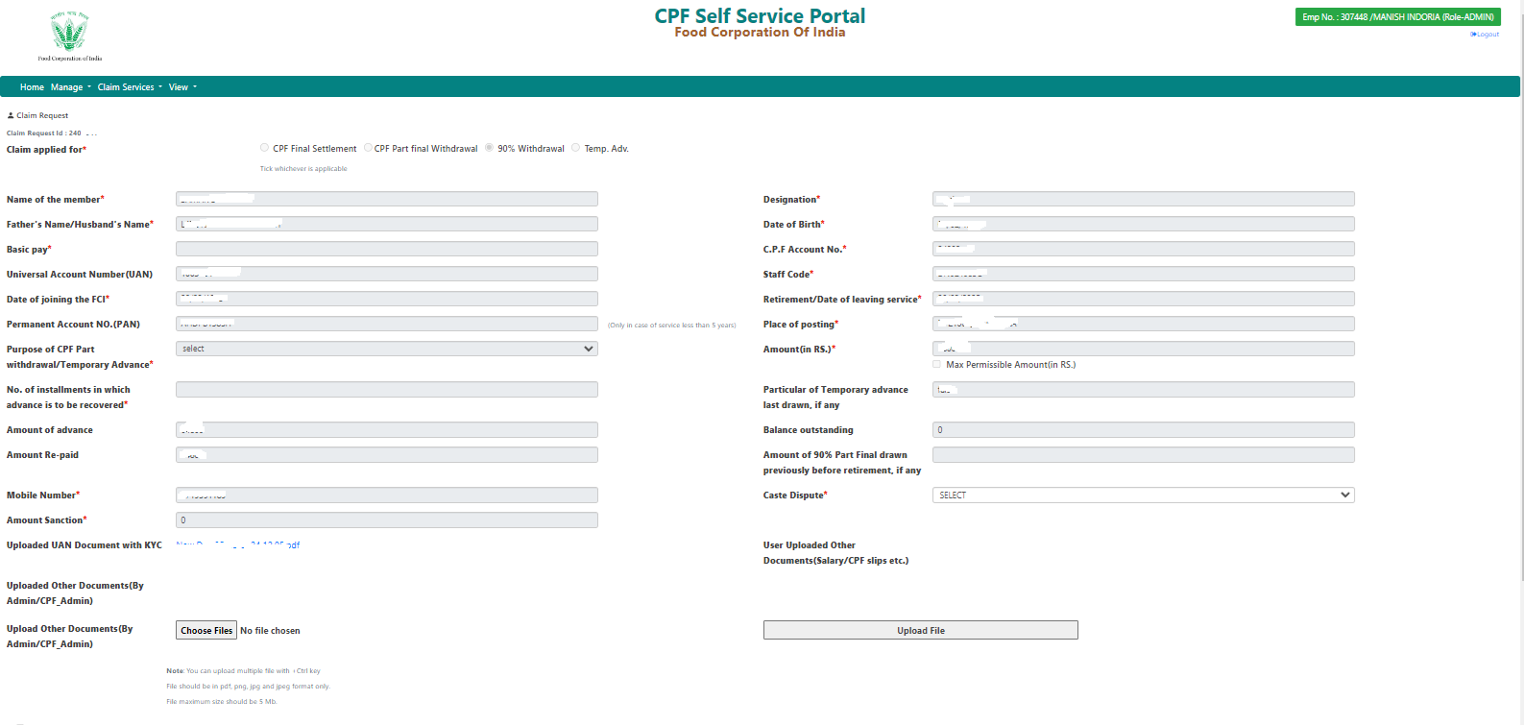
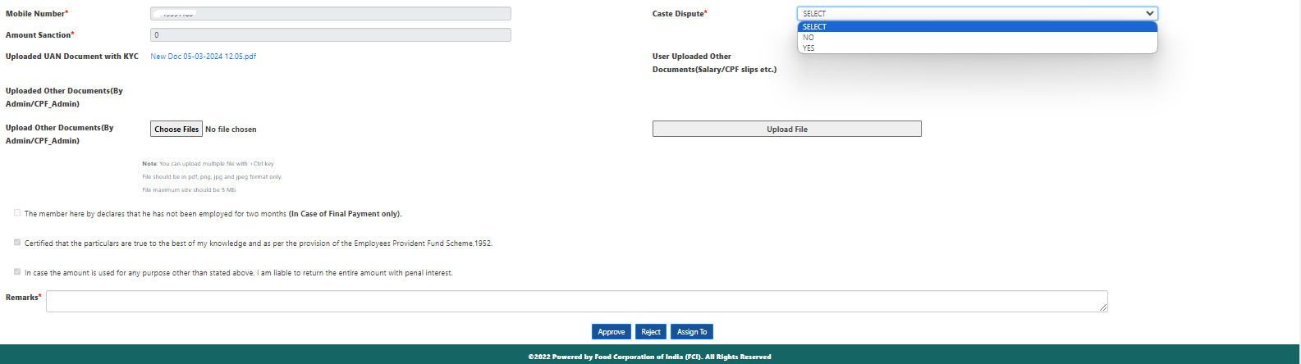

- Here Admin can take different actions like Approve, Reject, and Assigned to other Admin.
- If Admin goes for Approval, the system checks the parent zone for the applicant and then claims to move forward to that CPF Admin which has the same parent zone as of applicant for further approval.
- If Admin goes for Rejection, the claim has to move back to the User section for correction and then the User can re-apply the same claim.
- If Admin selects the “Assign To” option, the new screen will display.
- Here admin can select any unit name, on the basis of unit name location name have to populate automatically. Admin can select one of them and after location name selection administrator name populates automatically accordingly.
- Finally, give the remarks and click the assign to the button. “Assign To” operation performed by admin. Admin assigns the claim to other admin of any unit.
Note: - Admin can only assign to another admin of any unit instead of their own unit.
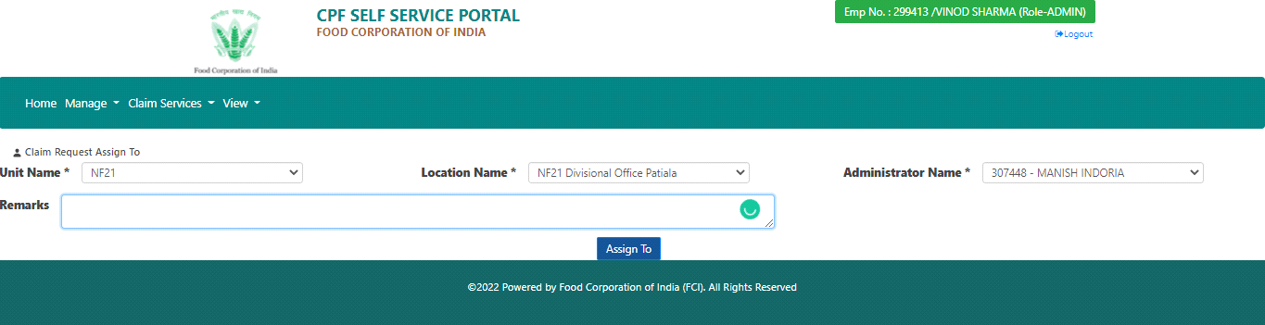
“Assign-To” Screen at Admin Level

Approved Request List –
Admin can see here all the requests which are approved by him.
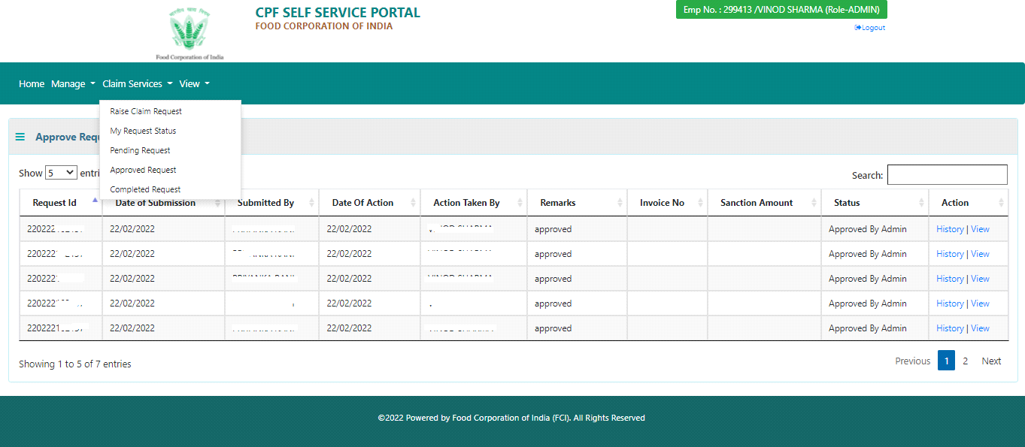

Completed Request List –
Here admin can see all those requests which are finally completed after CPF Admin approval.
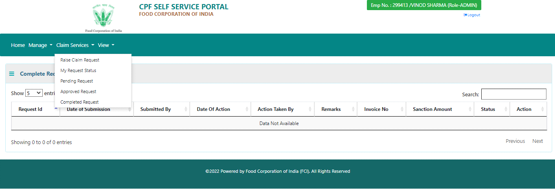

Requested Claim Report-
- Login with admin credentials in CPF Self Service Portal.
- Click on View main menu and go to the Claim Request Report option.
- Here you can view the requested claim records on the basis of the filter, which you have taken.
- CPF SSP provides you with five filters to generate the report.
- From and To date
- Employee Number
- Claim Type
- Parent Zone
- Claim Status Type

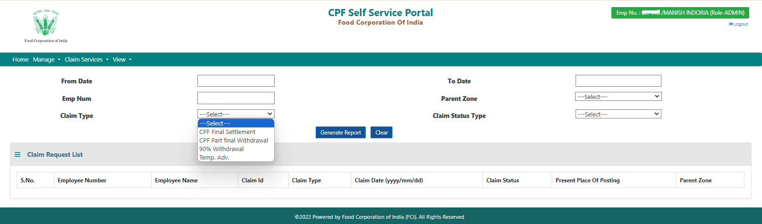
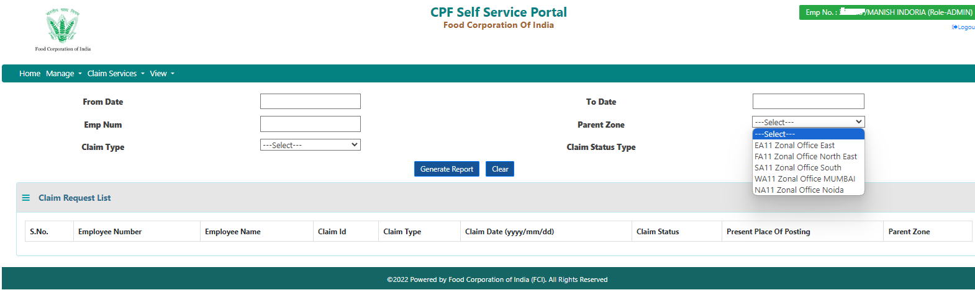
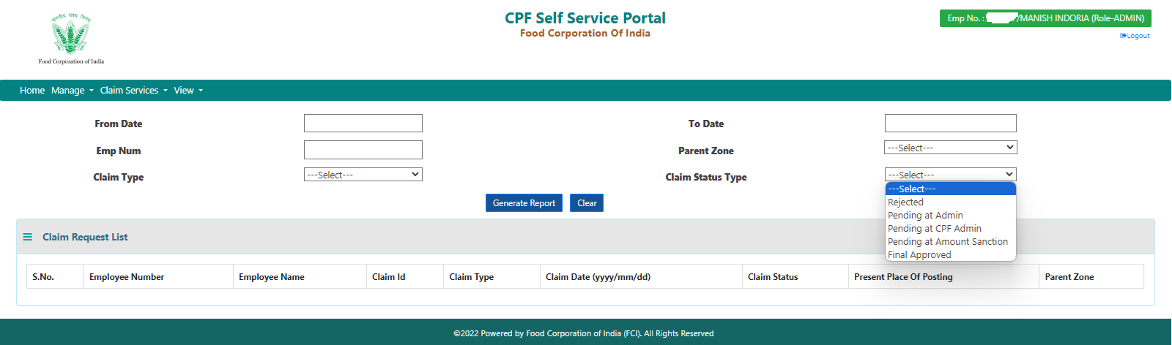
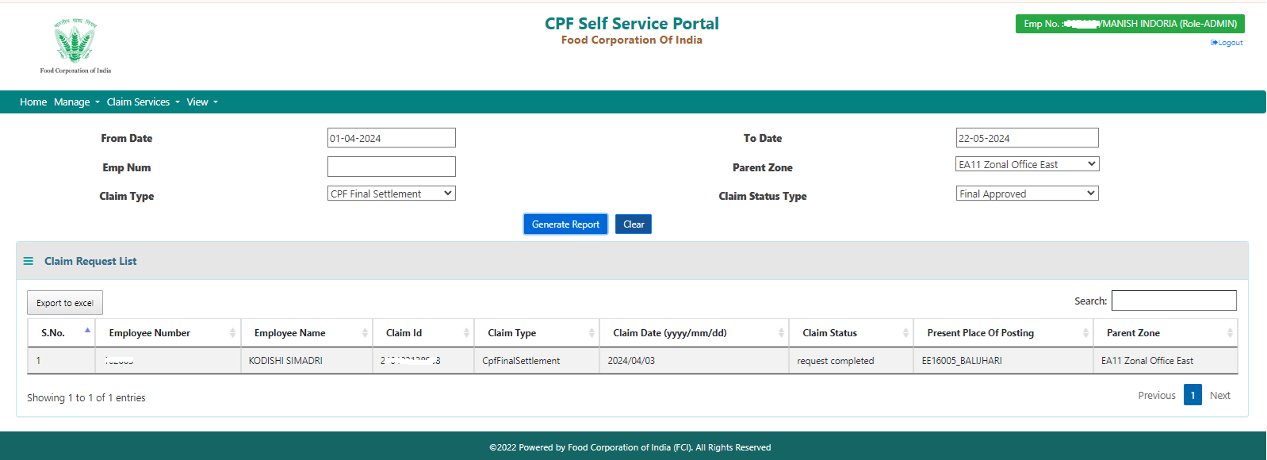
Note: Once you generate the report you can export it in excel format as well.

CPF Admin Login -
Claim Raise by CPF Admin -
CPF Admin can also raise their own claim using the ‘Raise Claim Request’ option, present inside Claim Service main menu. The page has been already displayed inside User Login Section. Once a claim is raised by CPF Admin can check and track their claim status by using the My Request Status option.

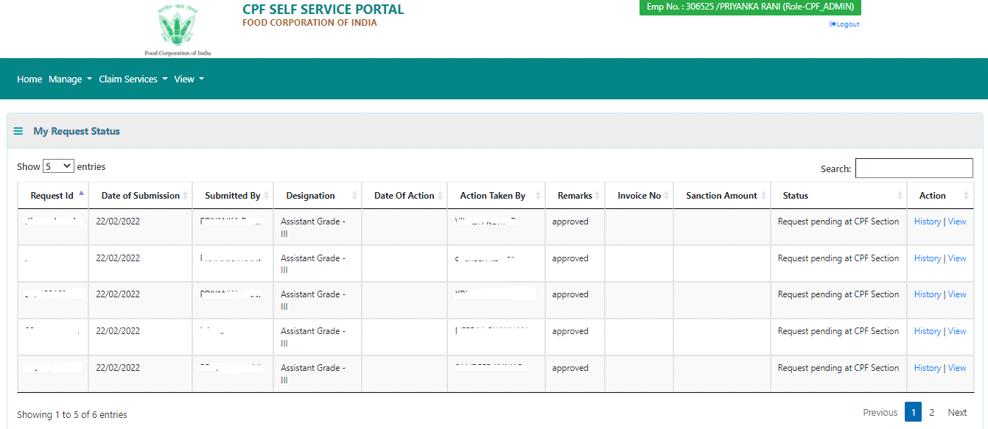

CPF Admin Approval –
- Login using CPF Admin credentials in CPF Self Service Portal.
- After successful login, the home page will appear.

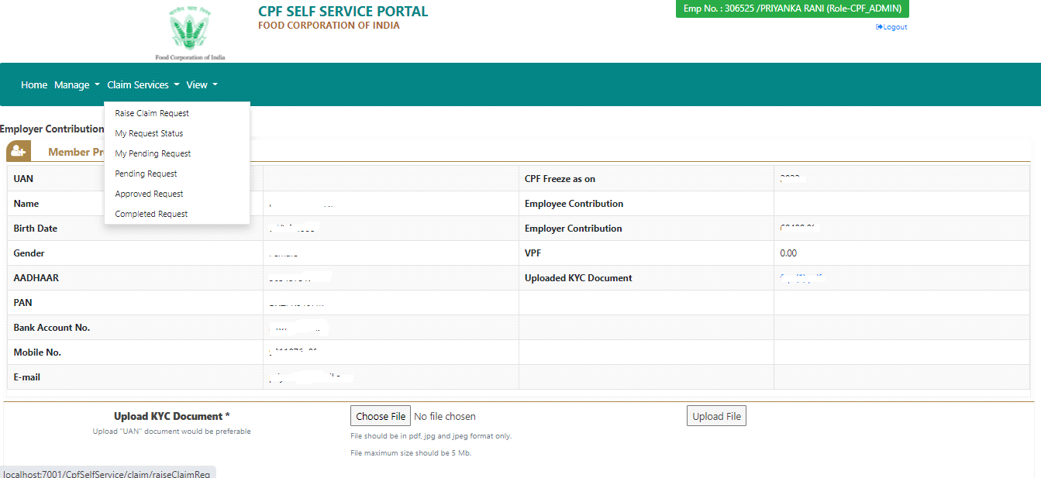
CPF Admin Home Page

- Now CPF Admin goes for pending claim requests by clicking on Claim Services –> Pending Requests. Get the list of all claims which come after Admin approval on Pending Request Status Page.

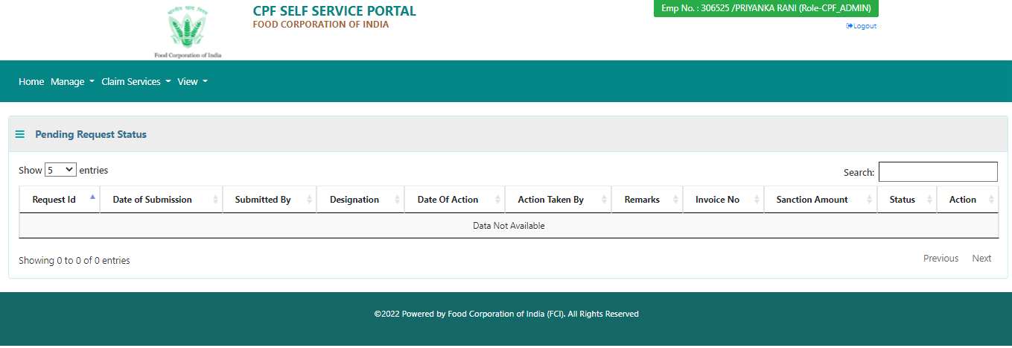

- Here CPF Admin can take any actions like Approve, Reject, and Assign-To on selected claim.
- Using the Assign-To option CPF admin assigns the claim to another CPF Admin within the same Parent Zone.
- Now, the claim will be reflected in the Claim Services -> My Pending Requests in the Login of the assigned CPF Admin.

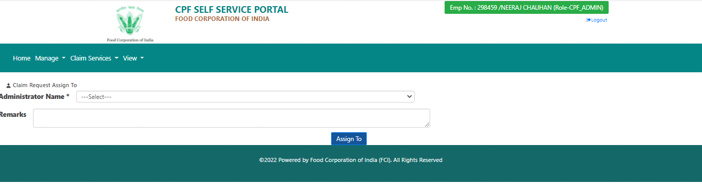Assign-To Screen at CPF Admin Level

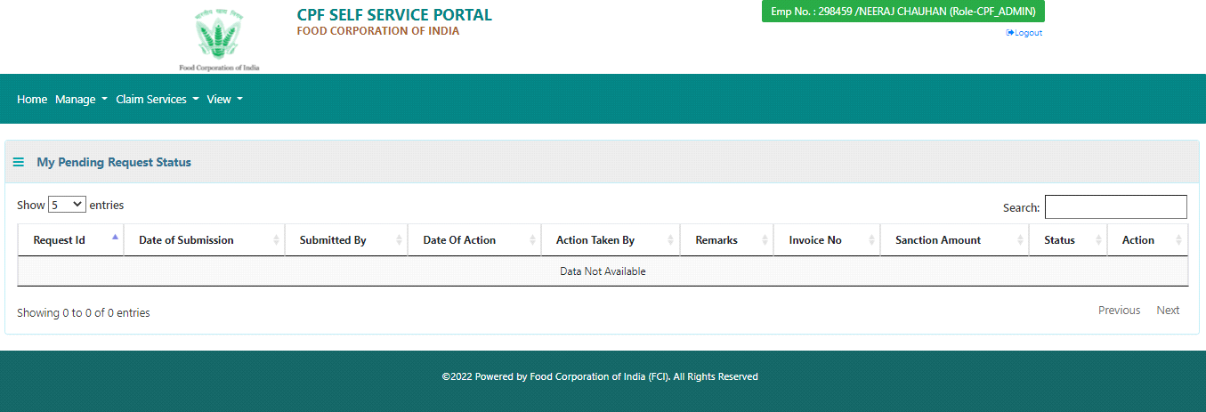Assign-To Request shown in My Pending Request Status Page

- After Approval, claim will go to the Payroll CPF Section and claim will display on ‘Complete Request Status’ page.

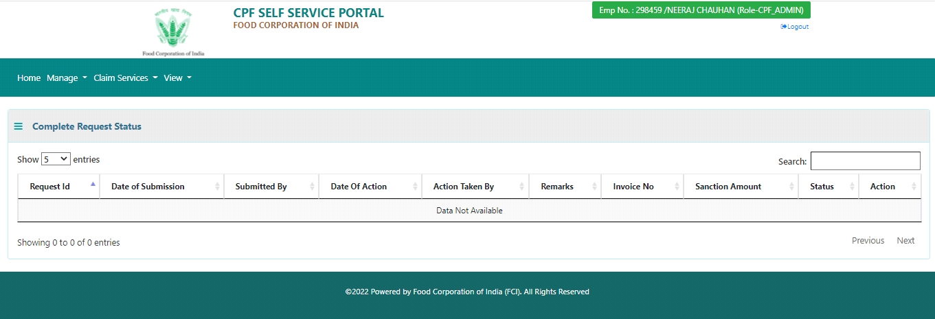

- At Payroll CPF System, authorized users can sanction the amount against CPF claim which is approved by CPF admin in CPF SSP system.
- After Sanction, create an invoice and Release payment in the Payroll System, Status of the Claim Status will be displayed as Complete in CPF Self Service Portal.
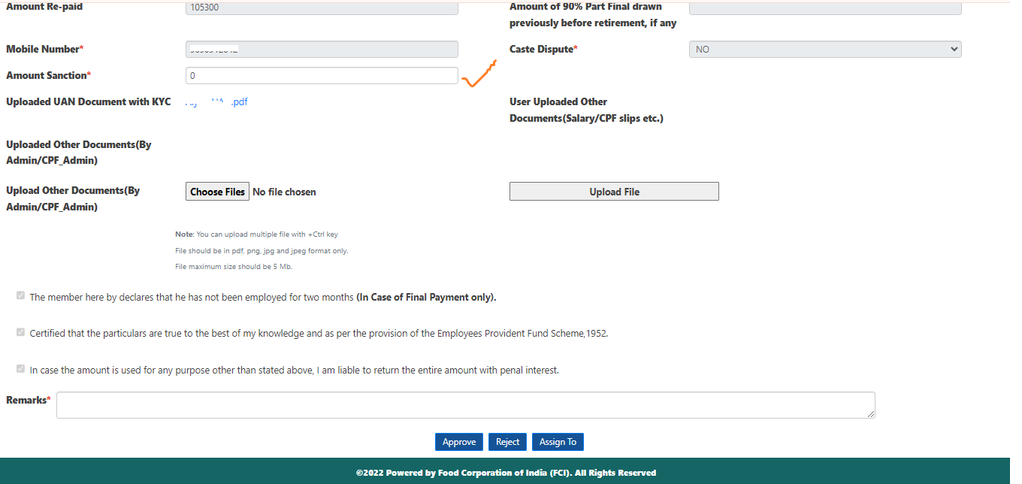

Note: - Our CPF SSP system supports that the CPF-Admin should give final approval of the applied claim by giving the maximum permissible amount or proposed amount along with a particular claim. Then, the payroll-CPF system should sanction the amount and generate their invoice.
If the CPF-Admin does not follow the above recommendation, the link between the CPF SSP portal system and the Payroll CPF system could be disconnected. In such a case, the technical team will seek back-end fixes to reestablish the link between the two separate systems.
Currently, the CPF-Admin can use the payroll CPF module to find the maximum permissible amount for an applied claim that is generated by the user.
Super User Login -
The super user section mainly handled role management features for all the employees who registered with CPF SSP. Role management performs two main actions assigning the role to the registered users and revoking the role to the assigned user.
When any employee registered with CPF SSP, the system automatically assigns the default role as USER. Then super user can change their role as ADMIN, CPF_ADMIN, OR SUPER_USER according to the requirement. Once assigned any role to the employee, a super user can revoke their role.
Note: - System does not support multiple roles on a single user id or employee id at a single point in time. If any employee wants to change after the assignment of role, then the super user needs to revoke their role first and then reassign the new role.
Manage Role -
- Login using Super User credentials in CPF Self Service Portal.
- Once login is successful, go to the main menu Role ->Manage Role option.
- Then super user gives the employee number and gets their details by clicking the 'Get Details' button.
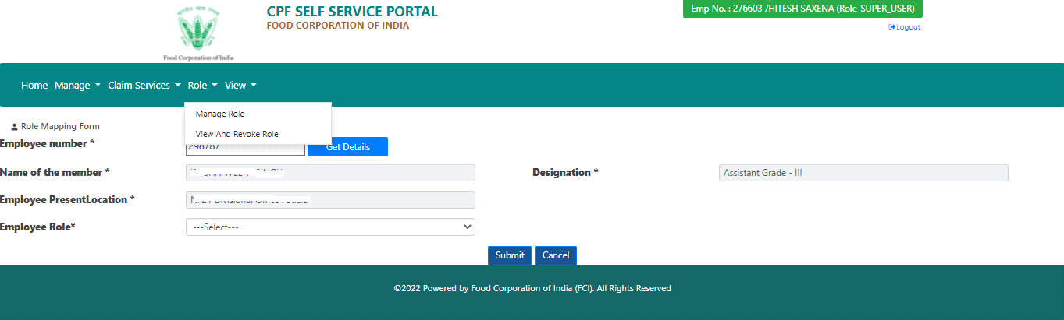
- Select Employee Role as ADMIN and then select employee unit as their present location.
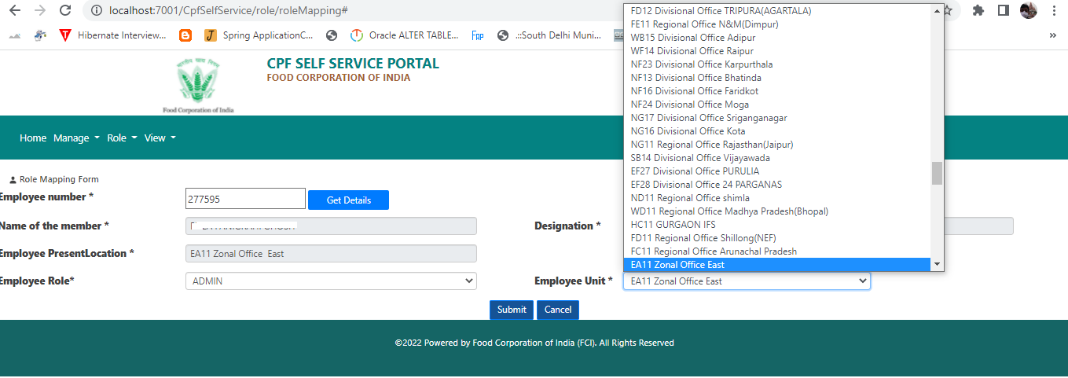
- If Employee Role selects as CPF ADMIN and then select parent zone as their parent zone.
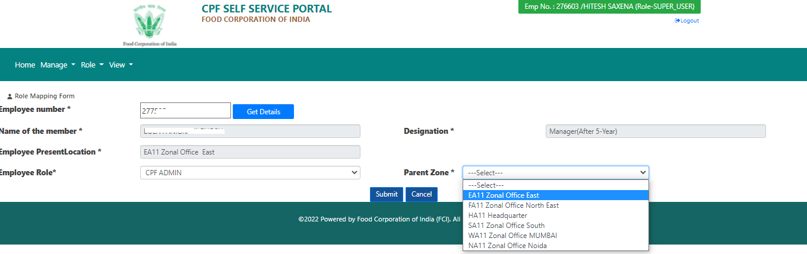
- Then click submit button for role assignment.
View and Revoke Role -
- Login using Super User credentials in CPF Self Service Portal.
- Once login is successful, go to the main menu Role ->View And Revoke Role option.
- The page will display to all ADMIN, CPF_ADMIN, and SUPER_USER users with the Revoke Role option along with all rows.
- Once super user clicks on the ‘Revoke Role’ option, the system removes the current role to that user and assigns the default role as USER.
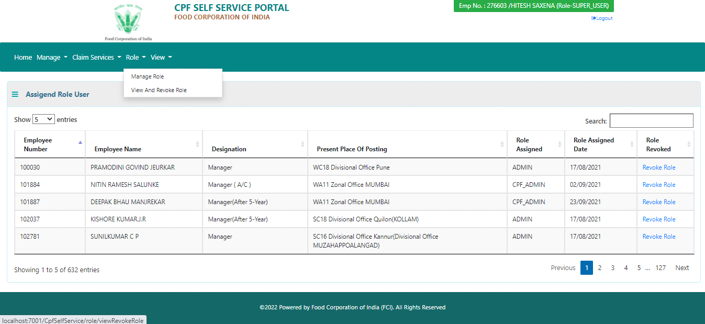

The rest of the things are already explained in the Admin and CPF Admin sections.
Note: - If a further modification occurs in any features which are explained above, will update accordingly.

